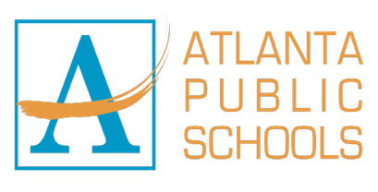 |  | 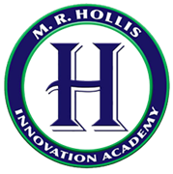 | M.R. HOLLIS INNOVATION ACADEMY  225 JAMES P. BRAWLEY, NW  ATLANTA, GEORGIA 30314  PHONE (404)-802-8200  Dr. Adib Shakir  Principal  adib.shakir@atlanta.k12.ga.us

July 14, 2025

Welcome to the 2025-2026 School Year at Hollis Innovation Academy!

Greetings M.R. Hollis Innovation Academy Families,

Welcome to the 2025-2026 school year! It is with immense excitement and great anticipation that we prepare to welcome our scholars back to the halls of M.R. Hollis Innovation Academy. We hope you have had a restful and joyous summer break and are ready for a year of learning, growth, and achievement.

As your new principal, I am excited to join the Hollis school community and serve as the lead champion for the success of every student. My career as an educator has been driven by the profound belief that every child possesses unique gifts and deserves a school that not only educates but also inspires and empowers them. I am committed to fostering a school environment where every student feels seen, valued, and challenged to reach their highest potential, and I am eager to get to know each of you as we begin this new journey together.

This year, our entire school community will be guided by a powerful theme: "Rooted in Purpose, Branded by Excellence."

Rooted in Purpose signifies our deep commitment to understanding the unique talents and aspirations of every child. It is our promise to provide an innovative and supportive environment where students are exposed to rich experiences that allow them to dream bigger and connect their learning to a choice-filled life. We are dedicated to ensuring that every lesson, every interaction, and every decision is grounded in the purpose of equipping our scholars with the knowledge and skills they need to succeed.

Branded by Excellence is our pledge to uphold the highest standards in everything we do. From the quality of our instruction to the strength of our school culture, we are committed to a standard of excellence that our students, families, and community can be proud of. This brand of excellence will be reflected in our academic rigor, our collaborative spirit, and our unwavering belief in the potential of every scholar.

The partnership between our school and our families is the most critical component of our success. We value your trust, your collaboration, and your active involvement in your child's education. We are truly in this work together.

I especially look forward to meeting many of you in person. We are incredibly optimistic about the journey ahead and are honored to be your partners in education. Thank you for your commitment to M.R. Hollis Innovation Academy. Let's make this a year of extraordinary purpose and excellence for every child.

Sincerely,
Dr. Shakir
Adib Shakir, Ed.D.
Principal

